Connections to Microcontroller

Keypad

Buzzer

LED

Start

Reset

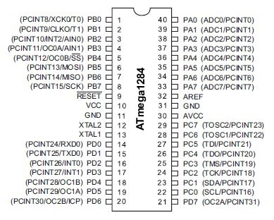

Nokia 5110 LCD

LED screen